Sampling procedure: sediment sections
OSL sampling
These notes are based on contexts where the sediments are not consolidated and can be driven into the strata without buckling.
Recording
- Prior to sampling, take a photograph of the cleaned section.
- Once sample locations have been selected (insertion of tubes) take a second photograph to show the location of the samples.
- Assign site code, context/sample number for each section sampled.
- Describe contexts (soil texture, sorting, particle size and colour) and produce a section drawing to show the contexts, record sample locations (depths below datum and showing position of ground surface) and contacts.
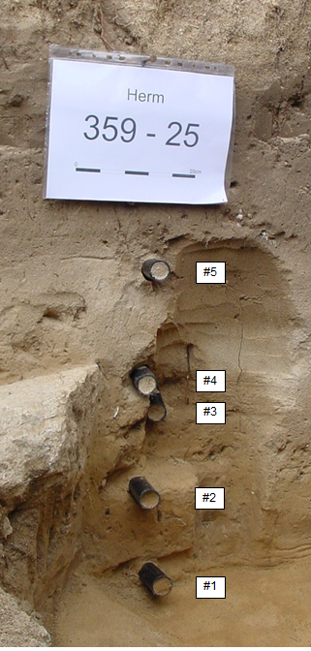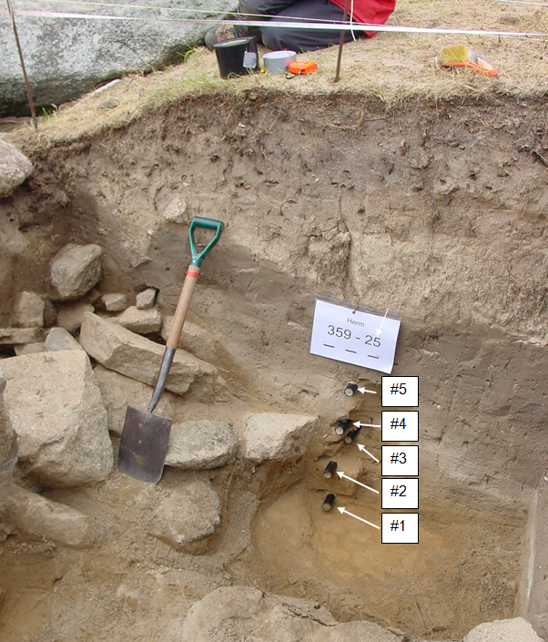
Herm, Trench S, Location 25 (tubes not fully inserted).
Sampling
- Only samples not exposed to light can be used for dating measurements - i.e., beyond ca 5 cm behind an excavated face and contained in an opaque sample tube or within the interior of a sediment block cut to provide material surrounding the sample volume of at least several cm.
- Black plastic or steel tubes (e.g. 40 mm dia) at least 15 cm long can be used for sampling where the sediment is not highly consolidated. The tubes should be fully packed with material with any space at each end filled to avoid mixing during transport.
- Tubes are taken from sedimentary units that are homogenous avoiding boundaries/thin units unless block sampled; in the case of a major interface, sample above and below the contact. If there are multiple thin layers, and the sediment consolidated, excavation of blocks is appropriate.
- If tubes are inserted above and below the contact at each interface, this will provide a sequence of samples, two from each layer (basal and upper).
- In addition to extracting sediment from the tubes for luminescence measurements, the material is also analysed for radionuclide concentration (U/Th/K) and for any given dating sample, samples of sediment representative of the major strata up to ca 30 cm from the dating sample are required. If these strata have not been sampled for dating (i.e. using tubes), smaller samples for radioactive analysis only may be collected in clear polythene sealable bags (25g is sufficient).
- Samples should be wrapped in opaque plastic sheet (use ‘lay-flat’ plastic tubing if available) and sealed with duct tape marked with site code, section, sample number, and direction of tube insertion (inner vs outer) should be clearly indicated on the tube.
Packing and transport.
- Tubes should be packed in a shock absorbing material to reduce the risk of disaggregation when transported.

Examples of Lay-flat tubing:
http://www.polybags.co.uk/shop/black-polythene-layflat-tubing_c1189.htm
http://www.speedypack.co.uk/black-polythene-layflat-tubing/

